Laboratory work on discipline
"Plant Physiology"
Title Subject: Physiology of plant cells. water metabolism
Lab. work 1. Effect of anion and cation salts on the form and time of plasmolysis
Purpose: To observe the effect of anion and cation salts on the form and time of plasmolysis.
Assignments:
1. Make a cut from the convex surface of the epidermis of colored onion.
2. Plasmolysis observe under a microscope by various salts.
Guidelines: A slice of the epidermis with the convex surface of the color onion are placed in a drop of the test solution of salt, cover with a coverslip and examined under a microscope. Watch the changing forms of plasmolysis. Determine the time of plasmolysis in each salt.
The results are recorded in the table.
Table
№ | Salt | Concentration | Time putting | Time of beginning of convex plasmolysis | Time of plasmolysis,  min
 | 1 Ca (NO3)₂ | 0,7 M
2 | KNO₃ | 1 M
3 | KCNS | 1 M

Title Subject: Physiology of plant cells. water metabolism
Lab. Work 2. Observing the cap plasmolysis
Purpose: Observing the cap plasmolysis
Assignments:
1. Make a cut from the convex surface of the epidermis scales of colored onion.
2. Place the cut in a drop of 1 M solution KSCN. Observe under a microscope.
Guidelines. Make a cut from the convex surface of the epidermis of colored onion, placed on a glass slide in a drop of 1 M solution of KSCN and cover with a cover glass. Sketched a single cell with a distinct cap plasmolysis. Write a conclusion.
Types of plasmolysis
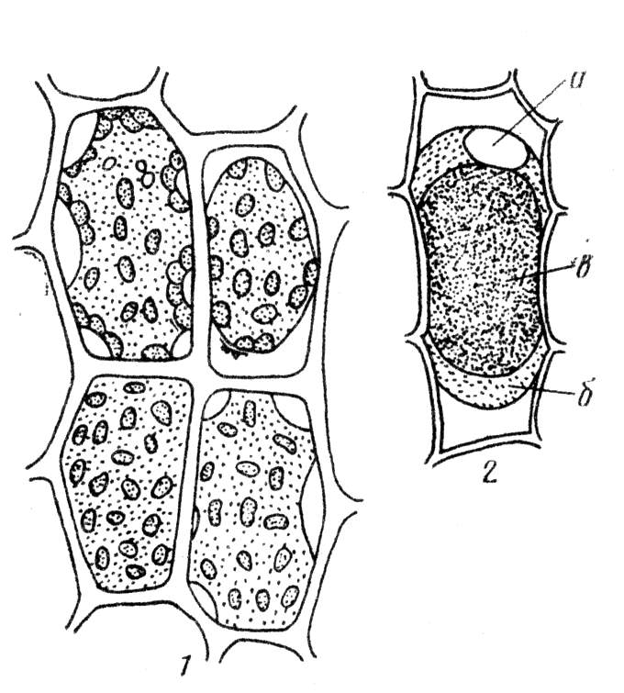
б
а
1 - Successive stages of plasmolysis in leaf cells of moss: a - Chevron (уголковый) plasmolysis, b - convex (выпуклый) plasmolysis.
2 - cells of the epidermis of onion scales with colored anthocyanin vacuole, -cap plasmolysis: a - nuclear, б – cytoplasm, в - the vacuole.

Title Subject: Physiology of plant cells. water metabolism
Lab. Work 3. Changes in the permeability of the cytoplasm under damage.
Purpose: Determination of potential osmotic pressure of the cell sap by method of plasmolysis. To determine the potential osmotic pressure of the cell sap by plasmolysis. Changes in the permeability of the cytoplasm under damage.
Assignments:
1. To prepare the solutions of different concentrations to obtain an isotonic solution.
2. To make a cut from the convex surface of the epidermis scales (чешуи) colored onion.
3. To place the slices in solutions with different salt concentrations.
4. To observe plasmolysis and calculate the potential osmotic pressure.
Guidelines. In preparing beaker 10 ml of 0.7 M, 0.6 M, 0.5 M, 0.4 M, 0.3 M, 0.2 M sucrose solution are prepared by diluting a 1 M solution of dist. water. To make the cut with a convex surface of the epidermis scales colored onion by blade, 2-3 slice are placed in a beaker. After 30 minutes, the slices were examined under a microscope. Determine the degree of plasmolysis cells in each solution and are isotonic concentration as the arithmetic mean of the concentrations at which plasmolysis just beginning and that at which plasmolysis does not observe.
Write in the table.
Concentration of sucrose, М | On 10 мл solution |  | Time of duration of tissue in the solutions |  | degree of plasmolysis | isotonic concentration | potential osmotic pressure of the cell sap
Concentration of sucrose, М | 1М sucrose | Н₂О, ml | Time of putting | time of observation | degree of plasmolysis | isotonic concentration | potential osmotic pressure of the cell sap
0,7 | 7 | 3
0,6 | 6 | 4
0,5 | 5 | 5
0,4 | 4 | 6
0,3 | 3 | 7
0,2 | 2 | 8

П=RxTxCxIх101,3, where
R-gas constant: 0.0821 atm/gradhmol; T-absolute temperature (273⁰S + room temp); C - isotonic concentration in moles; I - isotonic coefficient Vant-Hoff, 101.3 - factor to convert atmospheres in kilopascals. Write a conclusion.

Topic: Photosynthesis.
Lab. Work 4. Extraction of leaf pigments. Photosensitizing effect of chlorophyll on the reaction of hydrogen transfer. Alkaline saponification of chlorophyll.
Objective: To obtain an alcoholic extract of green leaf pigments.
Assignments:
1. To obtain an alcoholic extract pigments sheet.
Guidelines.
1. 1-2 g of leaves placed in a porcelain mortar, crush, add a little calcium carbonate or quartz sand and pounded. 4-5 ml of ethyl alcohol pour to his mass and then rubbed. After settling, the underside of the spout mortar lightly greased with Vaseline, and the green solution was carefully poured into a glass funnel with a paper filter.
The filtrate was transferred to a volumetric flask of 10 ml, the content of flask adjust to the mark with the solvent, cover the rubber stopper and shake thoroughly.
2. Separation of pigments by Kraus method.
Guidelines. In the test tube pour 2 ml of alcoholic solution of the extract of pigments and add 3-4 ml of gasoline. Contents of the tube is shaken strongly pre-closed hole. Gasoline emulsion layer will turn green because gasoline better solute chlorophyll then alcohol.
Carotene passes in petrol, but paint is masked by chlorophyll. Xanthophyll remains in the alcohol layer, giving a golden yellow color.
Draw the picture of the distribution of individual pigments.
Write a conclusion on lab. Work.
Purpose: To observe saponification of chlorophyll by adding of alkali.
Assignments:
1. In the test tube with separated by Kraus green leaf pigments add alkali and observe the saponification of chlorophyll by alkali.
Guidelines. In the test tube with pigments separated by Kraus method add dry alkali. Shake and boil. After boiling, the tube cooled. To the cooled solution an equal volume of gasoline and a few drops of water are added. The contents are then shaken and allowed to settle. Carotene and xanthophylls will move in the gasoline layer and sodium salt of chlorophyll acid will move in the alcoholic solution -.
COOC₂₀H₃₉ COONa
MgN_{4O}H₃₀C₃₂ +2NaOH → MgN₄OH₃₀C₃₂ + C₂₀H₃₉OH + CH₃OH
COOCH₃ COONa

Topic: Photosynthesis.
Lab. Work 5. Quantitative determination of chemical properties of leaf pigments.
Photosensitizing effect of chlorophyll on the reaction of hydrogen transfer by Gurevich
Purpose: To quantity the leaf pigments, observe the photosensitizing effect of chlorophyll on the reaction of hydrogen transfer.
1. Guidelines. Take 4 test tubes:
in the number of 1, 2.3 and 5 ml pour alcohol extraction of chlorophyll,
the 4th - 5 ml of ethanol.
In the number of 1, 2 and 4th tubes add 50 mg crystalline ascorbic acid and solution shaken.
In all tubes with chlorophyll alcoholic solution of methyl red are added br drops until the green color will change to red-brown.
In the 4th test tube color adjusted with methyl blue to bright pink.
Second tube is closed cover of black paper, then all the tubes are illuminated. A water-filled vessel is placed between the tubes and the light source.
After 10-15 minutes of lighting in the 1st test tube methyl red becomes colorless due to recovery and the solution is green. In test tubes color of the solution does not change, because the lack of light, ascorbic acid or chlorophyll methyl red is not restored leucoagent.
Fill the results of lab. work in the table
Variant | The mixture in the test tubes |  |  | Conditions of experiment | Results
 | Chlorophyl, ml | Ethanol | Saturated alcohol solution of methyl red | Conditions of experiment | Results

Draw a conclusion of lab. work.

Topic: Photosynthesis
Lab. Work 6. Determination of the rate of photosynthesis by assimilation flask.
Objective: To determine the rate of photosynthesis by assimilation flask.
Tasks: Identify the rate of photosynthesis by assimilation flask.
Guidelines. Take 2 bottles and wrap their throat pieces of paper.
Stand the flask for 20-30 minutes to fill with air.
Then simultaneously insert tube with holes, closed with glass stoppers.
Cut off a branch, update razor cut under water and place in a water-filled tube attached to a stick inserted into the cork.
Expose to the light bulb.
Duration of the experiment should be such that the leaves do not have time to absorb more than 25% carbon dioxide content.
Fill the results in the table
Sheet No. Ba(OH) 2 Number of HCl, Jr. Amendment titer Int Th f / s.

Objects Объекты | Time |  |  | Square of leaf | Amount of Ba(OH)2 | Amount of НCl, ml |  | Amendment titer Int | Photosynthesis intensity
Objects Объекты | Start | End | Duration | Square of leaf | Amount of Ba(OH)2 | experience | control | Amendment titer Int | Photosynthesis intensity
Write the results as conclusion of lab. work

Topic: Plants respiration
Lab. Work 7. Determination of the respiration of seeds in a closed vessel.
Objective: To determine the intensity of the respiration of seeds in a closed vessel.
Tasks: Identify the respiration of seeds in a closed vessel.
Guidelines. The method consists in accounting for the amount of CO2 released by seed respiration, CO2 is absorbed by barite.
Ba(OH)₂ + CO₂ + H₂O → BaSO₃.
Excess barite, not react with CO₂ is titrated with oxalic acid.
Ba(OH)₂ + H₂ → BaS₂O₄ C2O4 + 2H₂O.
Guidelines.
4 g of germinated seeds of wheat or rice is placediIn gauze bag. In two conical flask is filled with 10 ml of 0.1 N Ba(OH)₂ and stoppered.
In one flask, opening quickly append a bag of seeds, add 3 drops of phenolphthalein and titrated with 0.1 N barite oxalic acid to slightly pink color. Titrated as barite in the control flask. In the titration flask stopper through which the tip of the pipette attached to the bottle with barite.
Respiration rate (mg CO₂ allocated 1 g of dry seeds for 1 hour:
I = (a-b): kx2, 2 n,
where a and b - the number of 0.1 N oxalic acid at a cost of tirovanie barite, respectively, in the control and experimental flask, ml.7
For the correction to the titer.
2.2 - the amount of CO2 matching 1 ml of 0.1 N oxalic acid,
n - mass of dry seeds
Fill the results in the table
Experimental conditions | Weight of seed g | seed moisture,% | dry weight of seeds, g | Volume barite ml | Amounts of oxalic acid, ml |  | respiration intensity mg CO2 / g dry seeds
 |  |  |  |  | control | experience | respiration intensity mg CO2 / g dry seeds

Write the results as conclusion.

